Hi SEPA partners,
Wednesday, May 31st is “World No Tobacco Day” and this year's theme is “Grow Food, Not Tobacco”. To promote the event, we have created materials that you can use or share on various platforms:
- Web banner photos- these images can be used on your organization’s website and directed to PAHO’s website for acknowledging “World No Tobacco Day”, which will give visitors more information on the global campaign to raise awareness on how much land is used to grow tobacco instead of sustainable crops that provide food.
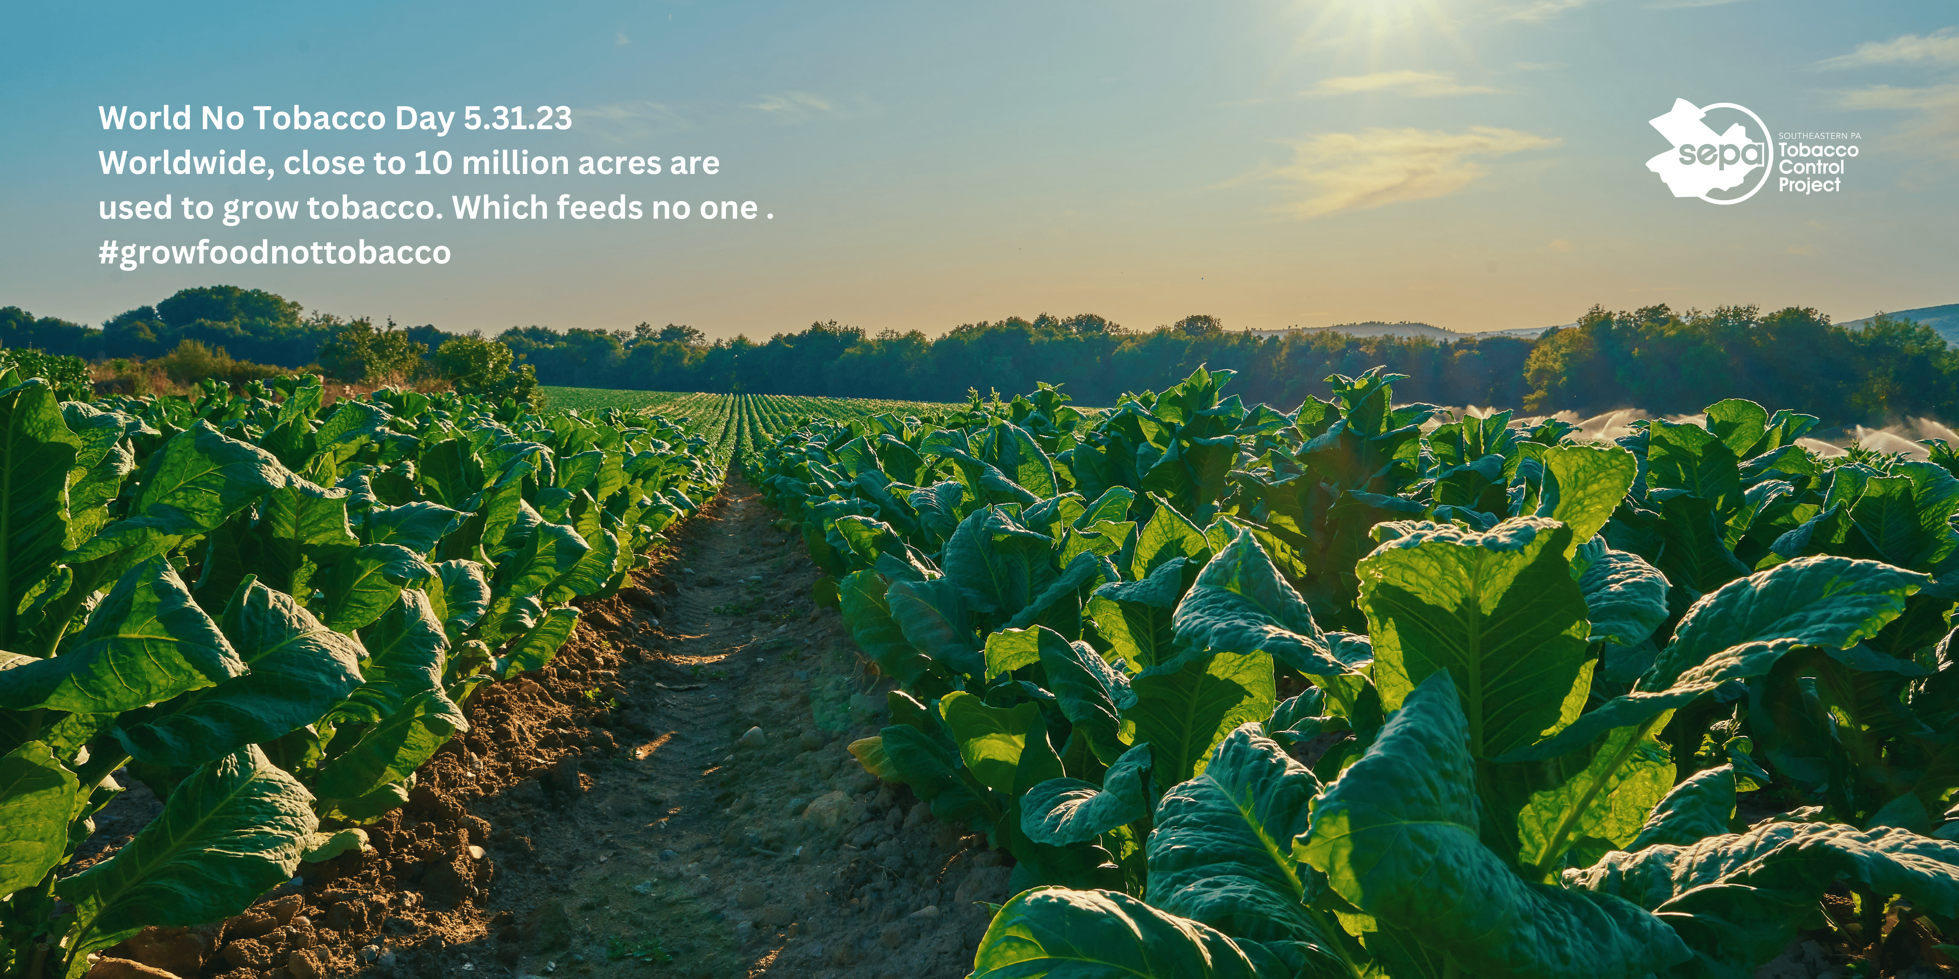
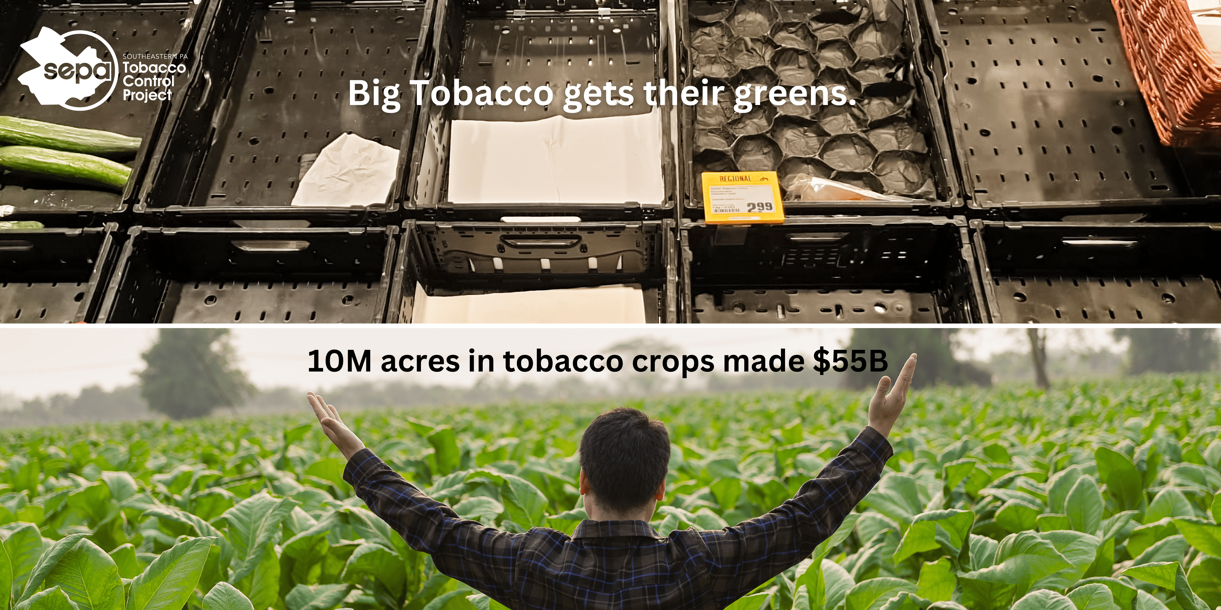

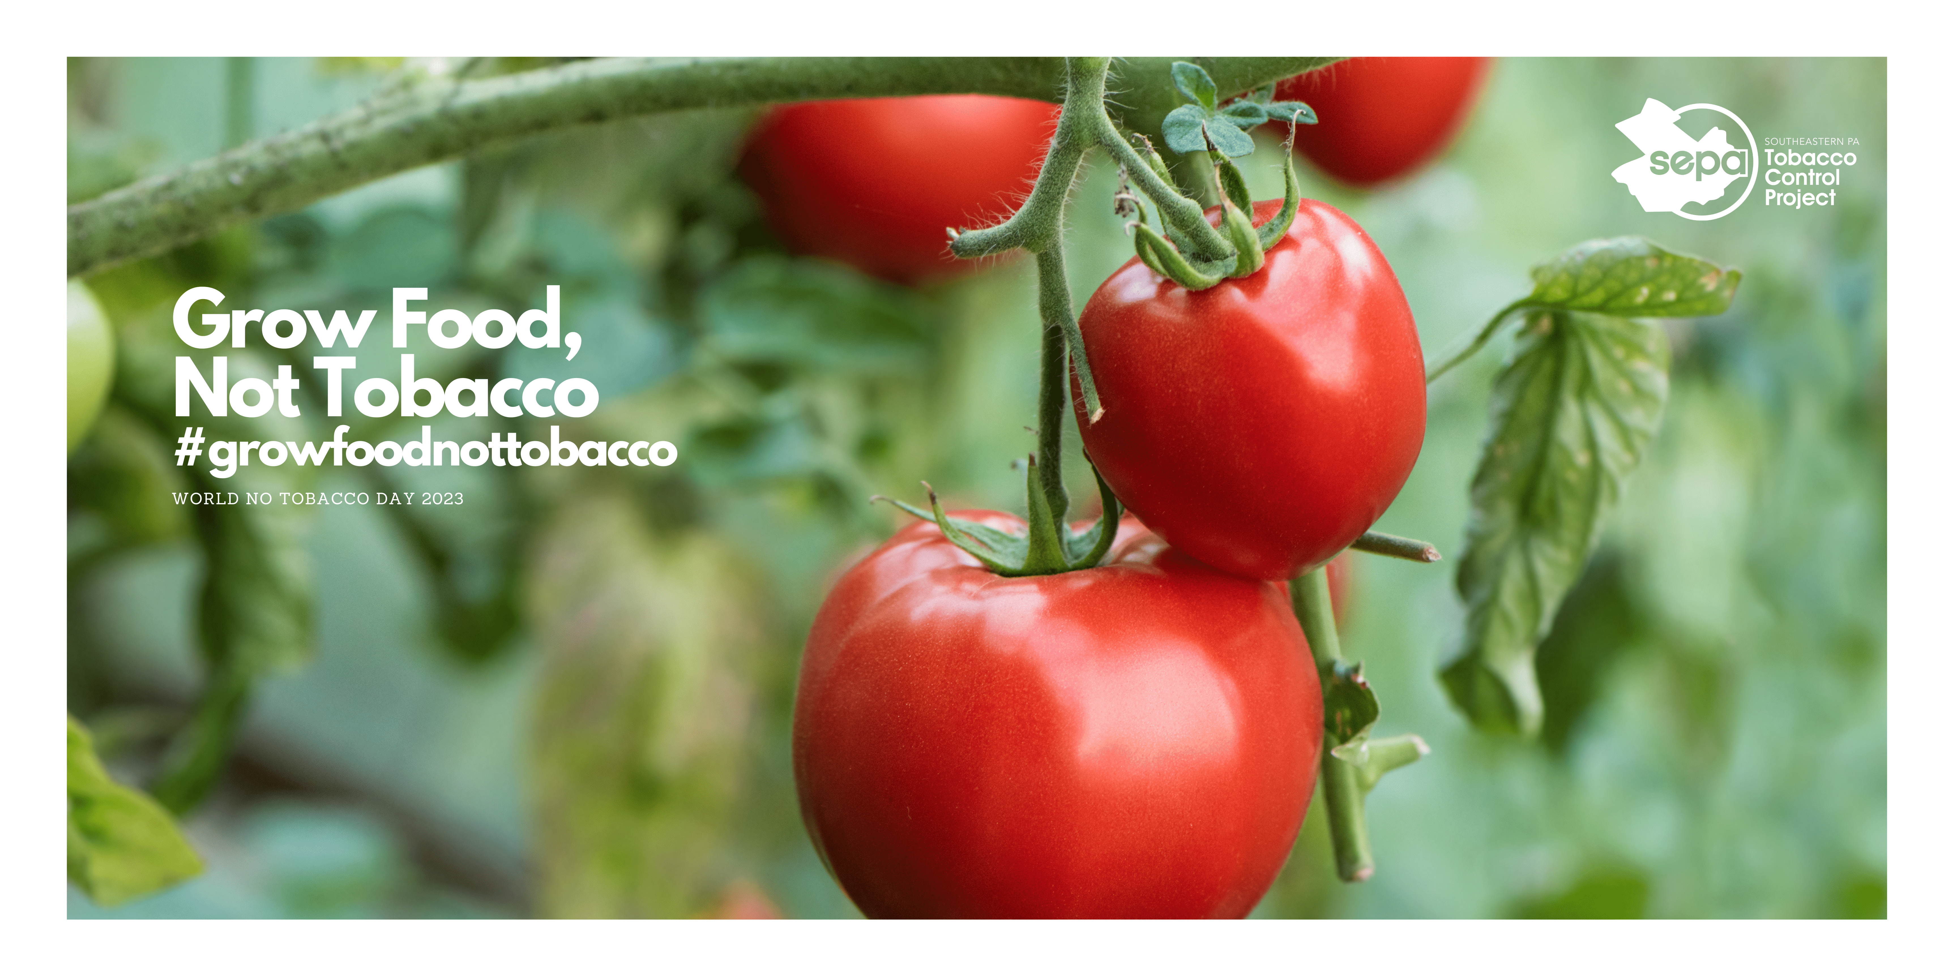

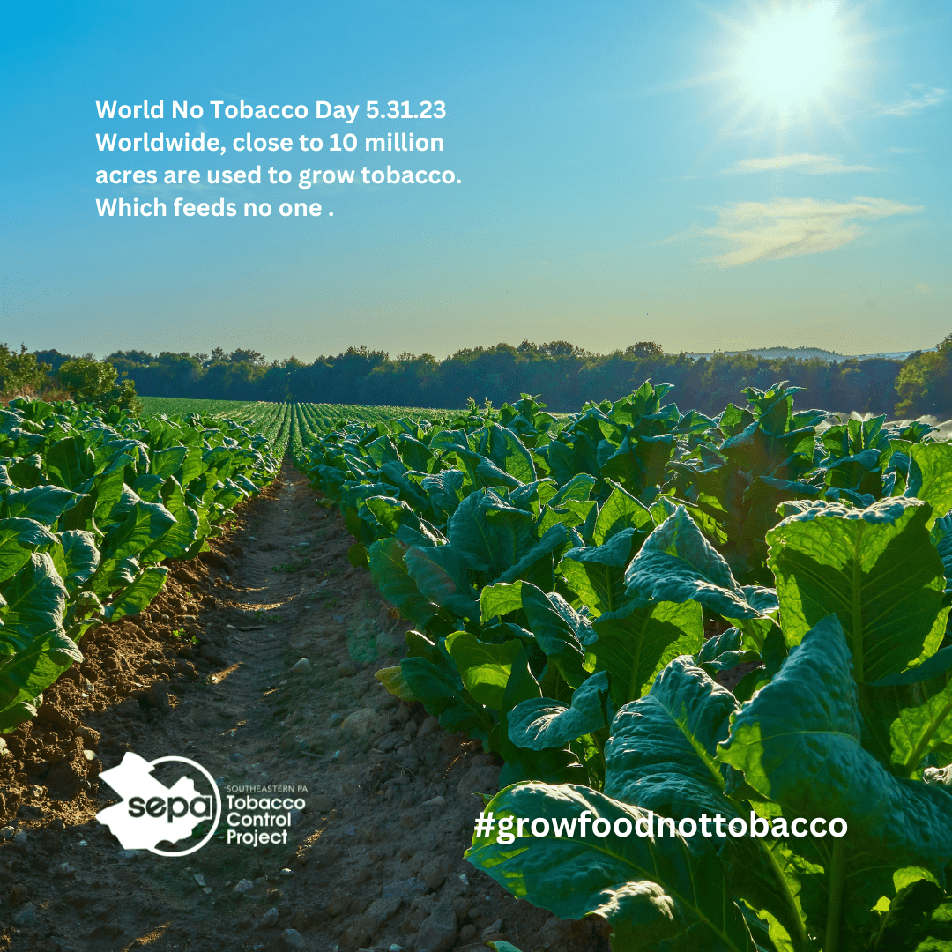
- Instagram or Facebook photo posts
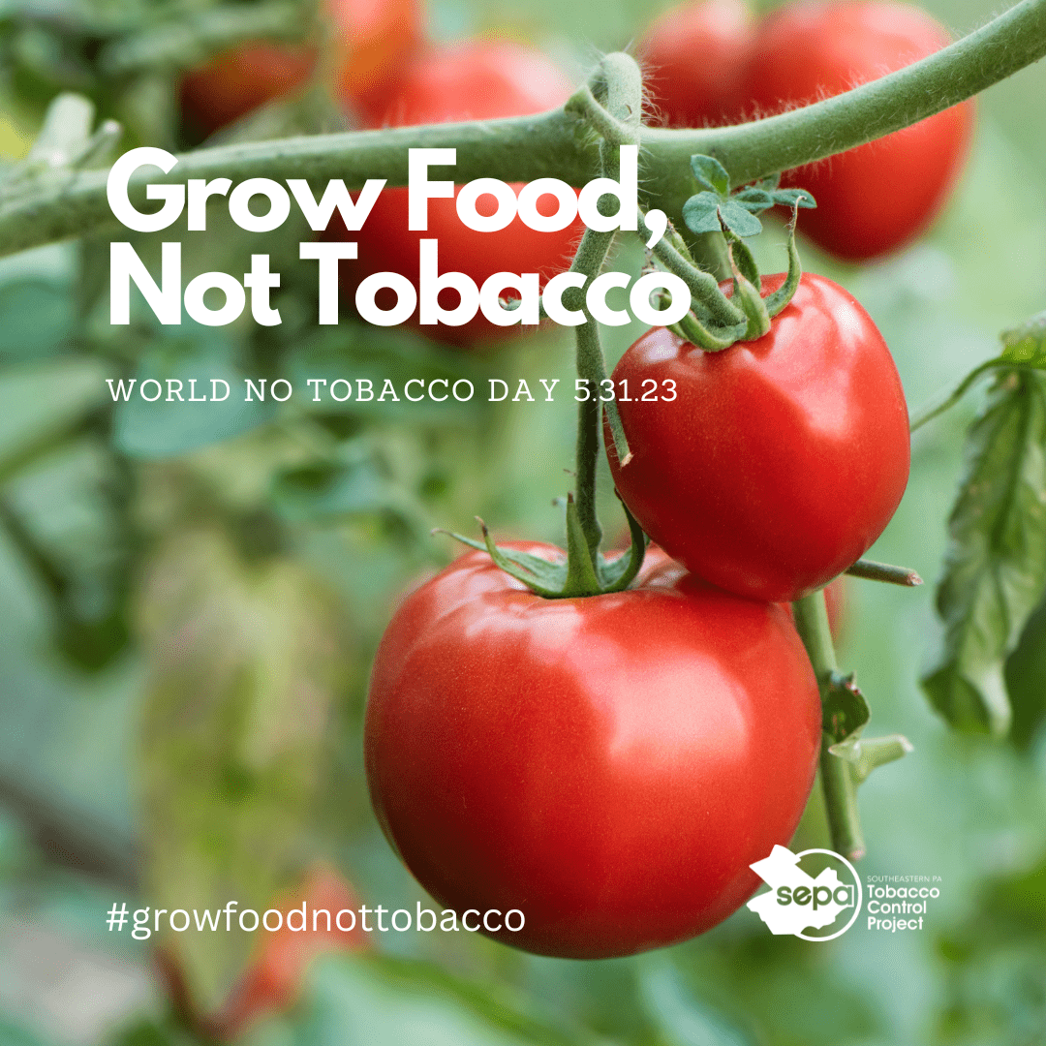
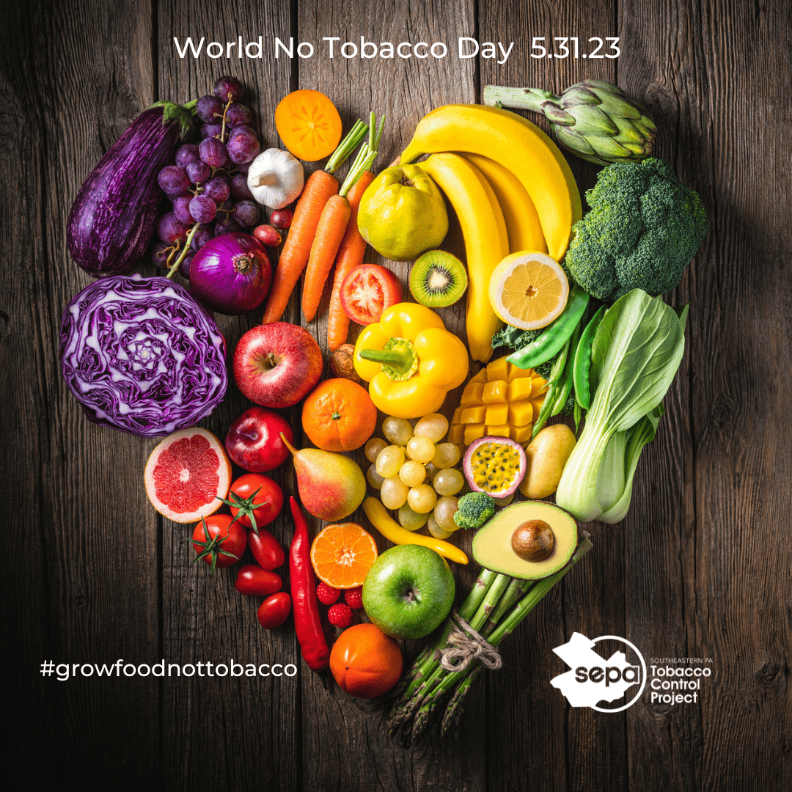

- Sample captions:
- 14M pounds of tobacco is harvest in PA yearly. More than 34 million people, including 9 million children, in the United States are food insecure. We need food, not tobacco. Say “no” to Big Tobacco. Need help quitting for good? Visit the PA FREE Quitline for resources or call 1(800)QUIT-NOW
- Close to 10 million acres are used for growing tobacco globally. We need food, not tobacco. Say “no” to Big Tobacco. Need help quitting for good? Visit the PA FREE Quitline for resources or call 1(800)QUIT-NOW
- Suggested hashtags:
#growfoodnottobacco #worldnotobaccoday #quitnow

Newsletter Draft:
May 31st is “World No Tobacco Day” and this year, the push is to grow food, not tobacco. Across the world, close to 10 million acres of land is used to grow tobacco (WHO.int). In Pennsylvania, around 5,500 acres produce a 14million pound tobacco harvest, equating to $38.5M in revenue. Support cutting tobacco farming subsidies and alternatively, growing sustainable crops that can help alleviate food insecurity. According to the USDA, more than 34 million people, including 9 million children, in the United States are food insecure. We need food, not tobacco. Raise awareness of the health burdens of commercial tobacco use (what tobacco farming tends to be used for in the US) and encourage quitting. A person who stops using tobacco or nicotine products will see their health improve immediately: after 20 minutes, their heart rate and blood pressure drops; after a few months, their circulation improves and their lung function increases. Quitting will help to lower the risk of diabetes, heart disease, and cancer. Need help quitting for good? Visit the PA FREE Quitline for resources or call 1(800)QUIT-NOW
For information on youth tobacco and vaping cessation resources, visit My Life, My Quit or text "Start My Quit" to 36072.

